Wellbeing Cause for Concern Form – Part 2

To be completed by the Class Teacher
Please note: This document must be completed by the Class Teacher. Parts 1 and 2 must be distributed to relevant staff prior to the GIRFEC meeting / Pupil Support Planning Meeting.
Name of Child: | Completed by: | Year Group:
New ☐ Ongoing ☐

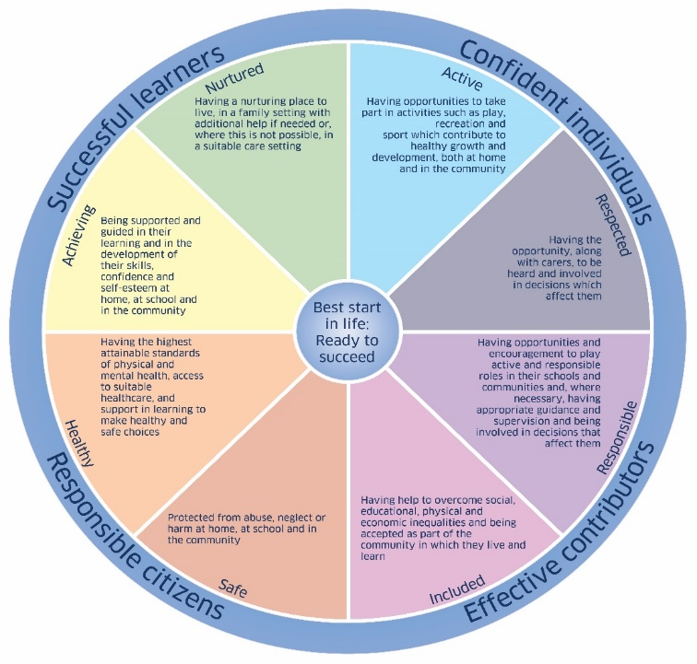

    - Have there been previous wellbeing concerns? Yes ☐ No ☐

If yes, please summarise with dates.

    - Has this concern been shared with the child/young person? Yes ☐ No ☐

If yes what is the child/young person saying about the concern

    - Has this concern been shared with the child/young person’s parents/carers?
Yes ☐ No ☐

If yes, please summarise with dates.

    - Has the concern been shared with anyone else? Yes ☐ No ☐

If yes, please summarise with dates.

    - What action is being taken in relation to this concern?

Continue to monitor

Bring the Child’s/Young Person’s Needs to a Pupil Support / GIRFEC

Planning Meeting

Initiate Child Protection procedures

Other – please give any details

    - Feedback to the referrer.
      - Name:
      - Role/designation:
      - Date:
Name of Class Teacher …………………………………………
Date………………………….
Keep Parts 1 and 2 in the Child’s Educational Records and copy to Pupil Support, unless pertaining to Child Protection when they should be given to the Child Protection Team in a sealed envelope.

