
Wellbeing Cause for Concern Form – Part 1

To be completed by the person who has the concern.
- Please ensure this completed document is passed onto the Class Teacher.
- The purpose of this form is to pass on wellbeing information about a child/young person through the routine support systems in our school.

- Child/ Young Person’s Details
Name: | DOB: | Class:

2. Person recording the concern
Name: | Role/designation:
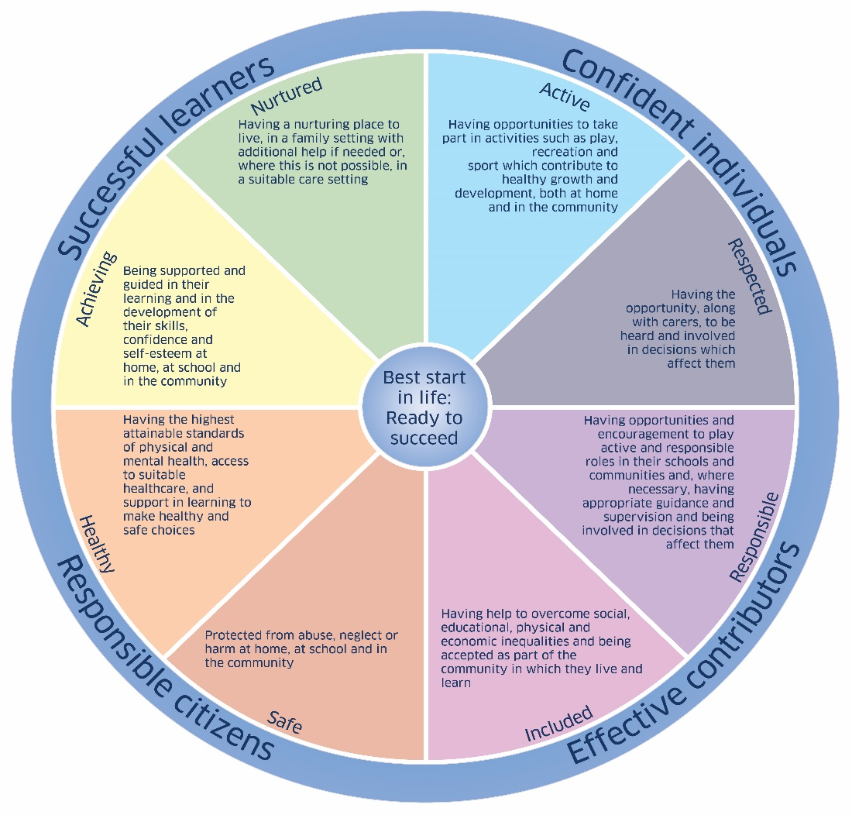
Areas of Concern. Please tick any relevant areas of the Wellbeing Wheel

☐ ☐

☐ ☐

☐ ☐

☐ ☐

Nature of Concern:
Use the headings you have ticked on the Wellbeing Wheel to record the details below:

Safeguarding/Child Protection Team informed, please tick in the box if done so. ☐

Previous Action Taken:

Signature: Date:

